

NCIA – National Cancer Imaging Archive

Software Design Description

Release 2.0 – Search Curation Data


Document Change Record
Version Number | Date | Description
1.0 | 06/28/06 | Initial document

TABLE OF CONTENTS
1. Introduction 1
1.1 PROJECT BACKGROUND 1
1.2 SYSTEM OVERVIEW 1
1.3 Requirements Traceability 2
1.3.1 Relevant Statement of Work Tasks 2
2. Use Cases 3
2.1.1 New Use Cases 3
Perform Search Based on Curation Data 3
2.1.2 Changes to Existing Use Cases 4
2.1.3 Perform Simple/Advanced Search Use Case 4
3. System Architecture 7
4. configuration 8
5. Sequence diagrams 9
5.1 query based on annotation keywords 9
6. Components 10
6.1 USER INTERFACE 10
6.1.1 Simple / Advanced Search Page 10
6.1.2 Annotation Keyword Search Page 10
6.2 User interface Backing Beans 10
6.2.1 SearchLookupBean 10
6.2.2 SearchWorkflowBean 11
6.2.3 CurationCdeDTO 12
6.3 MIDDLE TIER 12
6.3.1 LookupManager 12
6.3.2 CurationDataCriteria 13
6.3.3 CurationDataStringCriteria 13
6.3.4 CurationDataRangeCriteria 13
6.3.5 DicomQuery 13
6.3.6 DicomQueryHandler 13
6.4 UTILITIES 14
6.5 BACK END 14
6.5.1 Domain Classes 14
6.5.2 Database Design 15
6.5.3 Views 15
6.5.4 Indexes 15

Introduction
The purpose of this document is to describe the design for the Search Curation Data feature being developed for Release 2.0 of the NCIA – National Cancer Imaging Archive software.
This feature allows users to search for image data that has been curated by adding annotations data.

PROJECT BACKGROUND
Please refer to the NCIA Architecture Overview for background on the NCIA project.

SYSTEM OVERVIEW
Please refer to the NCIA Architecture Overview for a system overview.
.

Requirements Traceability

Relevant Statement of Work Tasks
The NCIA Statement of Work (SOW) Task Description contains the following items that will be implemented as part of this design:
4.1.11 Add Search Capability to Allow User to Search Annotations Data (4.1.3)
This task involves extending the advanced search page of NCIA to search annotations data that is stored as described in 4.1.8 above
▪ Assumptions:
o Search fields will be “ANDed” together (as is done for the existing search fields)
o Search fields will be displayed as appropriate based on the data type for each annotation data item

Use Cases
The requirements were documented by a combination of adding new use cases and updating existing use cases.

New Use Cases

Perform Search Based on Curation Data
Use Case Name | Perform Search Based on Curation Data
Use Case ID | 9.2
Primary Actor | Researcher
Trigger | Alternate course 1 of use case 9.1.
Pre-conditions
Flow of Events | - Researcher is presented with a read only list of criteria that have already been selected on the Simple / Advanced Search page.  - Researcher is presented with a distinct list of the CDE names of all curation data in the database for the collections selected on the previous page. If no collections were specified, the list displays CDEs for all collections that the user has access to.  - Researcher selects the CDEs that they want to search on.  - System determines the values currently in the database for each selected CDE.  - System determines the data type (string, date, or number) of each selected CDEs based on the values currently in the database for the CDE.  - For each CDE selected, user is presented fields to specify how to search based on the CDE.  - String CDEs: User is presented with a list of all values for the CDE that are currently in the database. User can select multiple values as criteria.  - Number CDEs: User is presented with fields that allow for the selection of a range based on the numbers (for example, > 4 and < 6).  - Date CDEs: User is presented with fields that allow for the selection of a from date and to date  - Researcher clicks on the submit button.  - The system then  - Validates the range criteria entered to ensure that valid values were entered  - Saves the query, the elapsed time to run the query and a timestamp of what was run in the user’s query history.  - Calls use case 9.6 (Filter Data in Results Based on CSM Authorization).  9. Displays the search results based on the selected criteria. Each type of criteria is ANDed with the other criteria. For example, if collections, slice thickness, and three CDEs were chosen as criteria, data returned must match one of the collections, be within the slice thickness parameters, and match at the values selected for each of the CDEs.
Post-Conditions | Success Condition: Researcher is presented with the search results screen to view the results (see use case 10.1).  Error Condition: Invalid Data or Incomplete Data.  Error Condition: System error while processing the search query.
Alternative Flow | User clicks a link to return to the Simple / Advanced Search page. System calls use case 9.1 (Perform Simple / Advanced Search).
Related Use Case | - 1.1 – Perform Simple / Advanced Search  - 10.1 – Display Search Results

Changes to Existing Use Cases
The changes relevant to this enhancement are highlighted in yellow.

Perform Simple/Advanced Search Use Case

Use Case Name | Perform Simple/Advanced Search Use Case
Use Case ID | 9.1
Primary Actor | Researcher
Trigger | Researcher has logged into the system and has clicked on the Simple or Advanced Search link from the main page
Pre-conditions
Flow of Events | - Researcher clicks on the Simple or Advanced Search link from the main page.  - Researcher is presented with a list of DICOM search fields to fill out. The following DICOM fields will be presented to the user.  - Simple Search - image modality, contrast, anatomic site, image slice thickness, presence of annotations and collection. The Collection field is filtered based on use case 9.7 (Filter Collection List on Search Page Based on CSM Authorization).  - Advanced Search – image modality, contrast, anatomical site, image slice thickness, minimum number of studies, number of months between baseline and final study, collection, manufacturer, model, equipment software version, series description, Convolution Kernel Type, and Kilo Voltage Peak Distribution.  - Researcher enters the fields to be searched and the condition for search (if any).  - Researcher clicks on the submit button.  - The system then  - Validates the data entered and  - Calls use case 9.6 (Filter Data in Results Based on CSM Authorization).  - Displays the search results based on the selected criteria. Each type of criteria is ANDed with the other criteria. For example, if collections and slice thickness were chosen as criteria, data returned must match one of the collections and be within the slice thickness parameters.  - Saves the query, the elapsed time to run the query and a timestamp of what was run in the user’s query history.
Post-Conditions | - Success Condition: Researcher is presented with the search results screen to view the results (see use case 10.1).  - Error Condition: Invalid Data or Incomplete Data.  - Error Condition: System error while processing the search query.
Alternative Flow | - Instead of clicking the submit button, Researcher clicks another button that allows them to also search by curation data.  - System validates the data entered and  - Calls use case 9.2 (Perform Search Based on Curation Data).  - If a validation error is thrown, the system displays the appropriate error and redisplays the page.  The actor can then  - Add additional data, edit entered data or clear the screen and re-enter all selections (return to step 3 above)  - Logout of the system and terminate the process.  - If a system error is thrown, the researcher is asked to contact the system administrator to report the type of error thrown.
Related Use Case

System Architecture
No changes are being made to the NCIA architecture for this enhancement.

configuration
There are no changes to configuration for this enhancement other than standard additions to faces-config.xml and tiles.xml related to user interface changes.

Sequence diagrams
For some use cases, sequence diagrams are helpful to illustrate the execution flow. Sequence diagrams are included this section for the appropriate use cases. Details of the objects that participate in the sequence diagram are described in section 6.

query based on annotation keywords
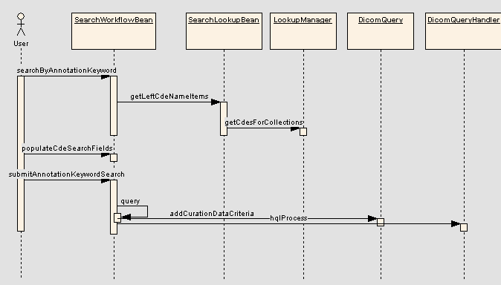

Components

USER INTERFACE

Simple / Advanced Search Page
Two changes will be made to the existing Simple / Advanced Search page:
- Add a new button named “Add Keyword Criteria” that takes the user to the new Annotation Keyword Search page
- Change to display list of selected criteria when the user has entered criteria on the Annotation Keyword Search and then navigated back to the Simple / Advanced Search page. If no curation data criteria has been entered, do not display the selected criteria list.
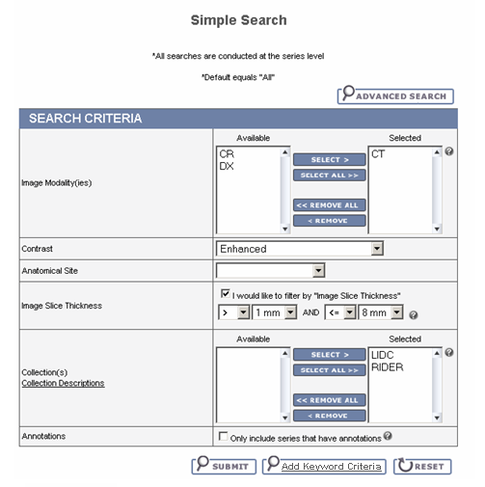

Annotation Keyword Search Page
This new page contains the following features:
- Display criteria that was previously selected on the Simple / Advanced search page
- A breadcrumb to navigate back to the Simple / Advanced search page. This button calls SearchWorkflowBean.backToRegularSearch.
- A list of CDEs that are available for searching based on the collections selected as criteria (explicitly or implicitly) on the Simple / Advanced search page. This list is accessed using the SearchLookupBean.leftCdeNameItems.
- A button named “Display Keywords” that will display all available CDE values for the CDEs selected from the CDE list. This button calls SearchWorkflowBean. searchByAnnotationKeyword.
- Once the “Display Keywords” button has been pressed, the list of selected CDEs and their values is accessed using the SearchWorkflowBean.selectedCdes attribute.
- A “Submit” button that calls SearchWorkflowBean.searchByAnnotationKeyword() to submit the selected CDE values as criteria.
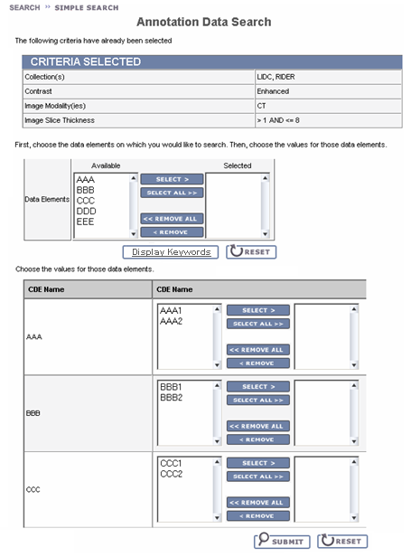

User interface Backing Beans

SearchLookupBean

The following new attributes will be added:
Attribute Name | Type | Description
leftCdeNameItems | List<SelectItem> | List of CDE names that appear on the left side of the CDE selection area of the page. Populate by calling LookupManager.getCdesForCollections and then getting a list of the names of all collections specified on the simple or advanced search page. If no collections were specified, get CDEs for all collections the user has access to.
rightCdeNameItems | List<SelectItem> | List of CDE names that appear on the right side of the CDE selection area of the page

SearchWorkflowBean

The following attributes will be added:
Attribute Name | Type | Description
selectedCdes | List<CurationCdeDTO> | List of DTOs representing CDEs selected for searching.

The following methods will be added:
New Method Name | Description
populateCdeSearchFields | Populates the selectedCdes list with DTOs representing CDEs selected in SearchLookupBean.rightCdeNameItems. Returns a string that causes the page to be refreshed displaying search fields for each selected CDE.
searchByAnnotationKeyword | Called when the user clicks the link on the Simple or Advanced Search page that will take them to the Annotation Keyword search page. Builds the DicomQuery based on any criteria selected. If there are any validation errors, returns a string that takes the user back to the Simple or Advanced Search page. Otherwise, returns a value that takes the user to the Annotation Keyword search page.
backToRegularSearch | Called when the user clicks the button on the Annotation Keyword search page to go back to the Simple or Advanced Search page. Populates the DicomQuery with CurationDataCriteria based on the selected CDEs and values. If there are any validation errors, returns a string that takes the user back to the Annotation Keyword Search page. Otherwise, returns a value that takes the user to the Simple or Advanced Search page (depending on which one they were previously viewing).
submitAnnotationKeywordSearch | Called when the user clicks the Submit button on the Annotation Keyword search page. Populates the DicomQuery with CurationDataCriteria based on the selected CDEs and values. If there are any validation errors, returns a string that takes the user back to the Annotation Keyword Search page. Otherwise, calls query() to run the query.

CurationCdeDTO

This class represents a CDE and all of its values for presentation purposes.
Attribute Name | Type | Description
cdeId | String | ID of the CDE
cdeName | String | Name of the CDE
isNumeric | Boolean | True if all values are numeric
stringValues | List<String> | If CDE is not numeric, contains all string values for the CDE
leftSideStringValues | List<SelectItem> | For non-numeric CDEs, list of values that appear in the left box of the search field
rightSideStringValues | List<SelectItem> | For non-numeric CDEs, list of values that appear in the right box of the search field
selectedValues | List<String> | For non-numeric CDEs, a list of strings representing values selected by the user
leftOperator | String | For numeric CDEs, the operator selected on the left side
leftValue | Double | For numeric CDEs, the value selected on the left side
rightOperator | String | For numeric CDEs, the operator selected on the right side
rightValue | Double | For numeric CDEs, the value selected on the left side

MIDDLE TIER

LookupManager

New Method Name | Description
getCdesForCollections | Accepts a list of collection names and returns a list of CurationCdeDTOs. This method queries the database to return a list of CurationData domain objects that match the trial names passed in. The domain objects are then grouped together in a map based on the CDE ID. Then, the system determines whether or not all values of the CDE can be made into a java.lang.Double. If so, isNumeric is set to true on the DTO. If not, all values of the CDE are placed into the leftSideStringValues attribute of the DTO.  If the same list of collections is passed in more than once, the system will use data stored in memory rather than go to the database.

CurationDataCriteria

This is a new abstract class that extends PersistentCriteria.
Attribute Name | Type | Description
cdeId | String | The CDE ID of the selected CDE

CurationDataStringCriteria

This new class extends CurationDataCriteria and is used when curation data is being searched based on a list of values.
Attribute Name | Type | Description
cdeStringValues | List<String> | List of values of the CDE that were selected

CurationDataRangeCriteria

This new class extends CurationDataCriteria and is used when curation data is being searched based on a list of range of values.
Attribute Name | Type | Description
fromOperator | String | From operator
fromValue | Double | From value
toOperator | String | To operator
toValue | Double | To value

DicomQuery

New methods must be added to contain the list of curation data criteria.
New Method Name | Description
addCurationDataCriteria | Adds curation data criteria to the query
getCurationDataCriteria | Gets a list of all curation data criteria

DicomQueryHandler

DicomQueryHandler builds HQL based on the criteria that is contained in the DicomQuery object passed to it. It must be modified to add filters to the HQL so that only results that match the selected CDEs will be returned. No additional queries will be added; the new conditions will be added as a subquery similar to how image level criteria is added. The subquery will return a list of series primary keys that match the curation data criteria.
The HQL must be built to match curation data at various levels:
- Trial – If a trial level CDE matches, return IDs of all series in the trial
- Patient - If a patient level CDE matches, return IDs of all series for the patient
- Study – If a study level CDE matches, return IDs of all series in the study
- Series – If a series level CDE matches, return the series ID
- Image – If a image level CDE matches, return the series ID of the series containing the image
- Annotation File – If an annotation file level CDE matches, return the series ID of the series to which the annotation file is associated
Numeric CDEs will be searched by using the NumericCurationData domain class; non numeric CDEs will use CurationData.

UTILITIES

BACK END

Domain Classes

NumericCurationData
This domain class is very similar to the CurationData domain being added for another enhancement. The only differences are that it only contains the required columns and the CdeValue column is a Double instead of a String.
Attribute Name | Attribute Type | Description
TrialName | String | Name of the trial
Patient | Patient | This will hold the Patient UID and the Patient PK ID
Study | Study | This will hold the Study UID and Study PK ID
GeneralSeries | GeneralSeries | This will hold the Series UID and Series PK ID
GeneralImage | GeneralImage | This will hold the Image UID and Image PK ID
AnnotationFile | Annotation | This will hold the Annotation File Path and the Annotation PK ID
CdeValue | Double | The value that the current CDE has for this data object.
CdeId | String | The ID of the CDE from caDSR.

Database Design
No changes.

Views

NUMERIC_CURATION_DATA
View: NUMERIC_CURATION_DATA
The purpose of this view is to allow for querying on curation data using ranges of numeric values. The view will return the CDE_VALUE as a NUMBER instead of a VARCHAR2 as in the CURATION_DATA table. The view will only contain data where CDE_VALUE can be converted to a NUMBER.
Column Name | Column Type | Class / Attribute Name
TRIAL_NAME | VARCHAR2 | NumericCurationData.TrialName
PATIENT_PK_ID | NUMBER | NumericCurationData.Patient
STUDY_PK_ID | NUMBER | NumericCurationData.Study
GENERAL_SERIES_PK_ID | NUMBER | NumericCurationData.GeneralSeries
IMAGE_PK_ID | NUMBER | NumericCurationData.GeneralImage
ANNOTATIONS_PK_ID | NUMBER | NumericCurationData.Annotation
CDE_VALUE | NUMBER | NumericCurationData.CdeValue
CDE_PUBLIC_ID | VARCHAR2(50) | NumericCurationData.CdeId

DDL:
select trial_name, patient_pk_id, study_pk_id, general_series_pk_id,
image_pk_id, annotations_pk_id, to_number(cde_value), cde_public_id
from curation_data
where length(trim(translate(cde_value, '.0123456789', ' '))) is null and
substr (cde_value, (instr(cde_value, '.', 1, 2)), 1) <> '.';

Indexes
Indexes will be added as needed to CURATION_DATA to improve performance.

